There is a clear relationship b/t latitude and temperature. The temperature rises from the South Pole to towards the equator (positive slope), and then falls from the equator toward the North Pole, as one would expect.

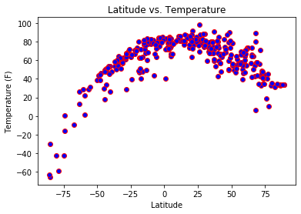

-----------------------------------------------------------------------------------------------------------------------------------

There is no clear relationship between latitude and either of the variables of humidity, cloud cover, and wind speed.

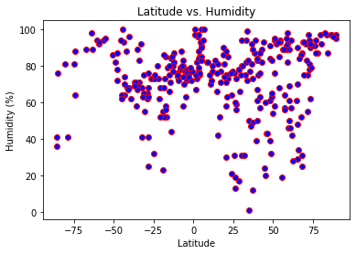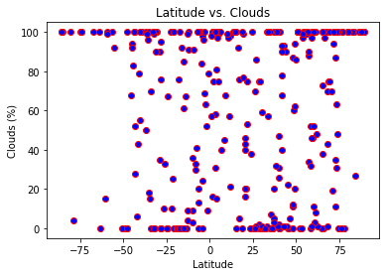 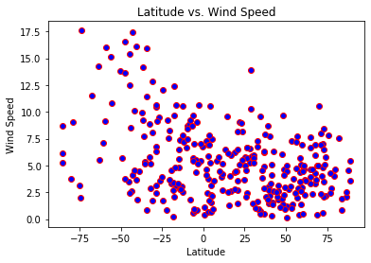

____________________________________________________________________________________

There is no clear relationship between latitude and wind speed. However, there does appear to be higher wind speeds as you get closer to the South Pole for some reason. My only theory is that there was some kind of arctic hurricane over Antartica on that day.

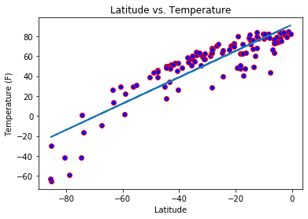

R-squared = 0.79

The latitude vs. temperature, isolated to just the Southern Hemisphere, shows a strong linear relationship as I spoke of earlier. The R-squared was almost 0.8. Of course there will always be local variations in temperature due to local weather patterns.

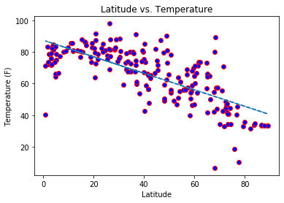

R-squared = 0.52

The latitude vs. temperature, isolated to just the Northern Hemisphere, shows a less strong linear relationship, with an R-squared of about 0.5. My theory is that it is known that most of the Earth’s land is in the North Hemisphere. It might be due to the variations in elevation and other geographic features that the temperature is much more variant.

